Transition Documentation For KITS – Darwin Build&Development

Version 1.1



TCS House, Rave line Street, Fort
Mumbai 400 001,India
December 2012

Transition Documentation 5

0.1 Training Status
0.1.1 Service Delivery Team Transition
OVERALL END TO END PROCESS........................................................................................5-7

0.2 Development and Build Process 8
0.2.1 Introduction to Nexus.......................................................................................................................................8
0.2.2 Introduction to SONAR...............................................................................................................................8-13

Transition Documentation
Purpose

The purpose of this document is to provide a comprehensive understanding of the Build and Development process to be followed by TCS. It also references the various platforms required in the efficient development process.

0.1 Training Status

0.1.1 Service Delivery Team Transition

OVERALL END TO END PROCESS

- Requirement specification provided by the client.
- TCS analyses the requirements and prepares the Technical Design Documentation(TDD).
- Setting up development environment (ECLIPSE IDE configured with PMD ,CHECKSTYLE, FIND BUGS etc for quality checks, Oracle installation for database,setting up Virtual Machine(in our case).
- Developers in the offshore pulls code from GITHUB repository (currently from TCS_MASTER for store locator) using the following command-
git pull --rebase origin TCS_MASTER
5.Developers then needs to create local branch using the following commands-
ii)git push origin <local_branch_name>
6. Then developers need to build the codes locally in the following order to check the status of the code-
i)Common modules and Call Center Modules
buildr clean install -e comm
buildr clean install -e ccm​
buildr clean install -e cca

ii)For building publishing ear -
buildr clean install -e tpm
buildr clean install -e tpa

iii)For building fulfillment ear-
buildr clean install -e ffm
buildr clean install -e ffa
  - Now after getting the latest code the developers starts developing their respective modules in eclipse
  - The developers will follow test-driven development using JUNIT TEST CASES.
  - Then the developers need to build and test their code by executing the same commands as mentioned above.
  - The ear then needs to be deployed in a local application server / developer’s VM where a round of functional & UI sanity test will take place using Fitness scripts or manual testingOnce that succeeds the developers then will commit their code in the local branch that they have created by using the following commands-
i)git add
ii)git comment -m "Comments"
iii)git push origin <local_branch_name>
11. Once that succeeds the developers then will commit their code in the local branch that they have created by using the following commands-
i)git add
ii)git comment -m "Comments"
iii)git push origin <local_branch_name>
12. Then the developers need to pull the code from the TCS_MASTER branch using the following commands-
i)git checkout TCS_MASTER
ii)git pull --rebase origin TCS_MASTER
13. Then merging of codes needs to be done with the local branch using the following command-
git rebase <local_branch_name>
14. After the merging the codes meeds to be built using the commands mentioned above in the document.

15. Once the build is successful the codes needs to be pushed in the TCS_MASTER branch.

16. Once the code is pushed into the TCS_MASTER branch the CI process will get triggered.
17. In CI process once the codes are pushed Jenkins jobs will be triggered.
18. First codes will be pulled from the specified branch and build will take place
19. Once the build is done the artifacts are sent to sonar server where Quality checks are done using Findbugs, Checkstyle, JavaPMD, etc. are done. (Introduction of sonar is mentioned below )

20. Once the analysis is done the ear will be deployed in SQA (Sprint QA) environment.

21. After the deployment regression testing of the business functionalities will be done using Fitnesse Test suites.

22. Once that succeeds the ear will be uploaded to nexus repository.(Introduction of nexus is mentioned below )

23. Then the ear will be deployed in various environments (QAM, SUAT, PIT) for further testing of the functionalities.

24. Functional testing for the new module will commence in the QAM environment. This will be a mix of manual and automated tests using Fitnesse.

25. Once the functional testing completes, code will be deployed in SUAT for acceptance test by KITS product owners. Once deployed, a sanity check needs to be done to ensure the deployment is successful.

26. Post SUAT validation, the ear will be deployed in PIT environment and integrated with external systems. One round of integration testing will be performed in this environment.

27. After PIT the ear will be deployed in SIT,UAT,PVT,QPFT where integration testing will be performed by other client vendors and from client side.

28. Finally the ear will be deployed to production environment.

  - Development and Build Process :

0.2.1 Introduction to Nexus:

Nexus is a repository manager that provides a platform for the storage, retrieval, and management of binary software artifacts,meta data for use in development and meta data for use in development & deployment

.
It helps to share those artifacts with other developers and end-users, and thus lowers build times, and improves visibility and control over component usage.
It helps to achieve a more efficient development cycle.

Uses- Nexus
It is used to store by versions,share & manage software build artifacts required for development.
A repository stores two types of artifacts:
- releases
- snapshots

0.2.2. Introduction to SONAR:

An open source Platform used by development teams to manage source code quality
Make code quality management accessible to everyone with minimal effort

Sonar enables to cover quality on 7 axes and so to report on:
1)Duplicated code
2)Coding standards
3)Unit tests
4)Complex code
5)Potential bugs
6)Comments
7) Design and architecture

How to manage source code quality?
There are seven technical axes that should be looked at when doing source code analysis of a project and Sonar is able to support the management of all seven.
- non respect of coding standards and best practices
- lacking comments in the source code, especially in public API
- having duplicated lines of code
- having complex component or/and a bad distribution of complexity amongst components
- having no or low code coverage by unit tests, especially in complex part of the program
- leaving potential bugs
7. having a spaghetti design

How does Sonar work?.

Sonar is made of a fairly simple and flexible architecture that consists of three components:
1)A set of source code analyzers that are grouped in a Maven plug in and are triggered on demand. The analyzers use configuration stored in the database
2)A database to not only persist the results of the analysis, the projects and global configuration but also to keep historical analysis for Time Machine
3)A web reporting tool to display code quality dashboards on projects, hunt for defects, check Time Machine and to configure analysis.

The home page of the application shows the list of projects under quality control with a few configurable metrics:

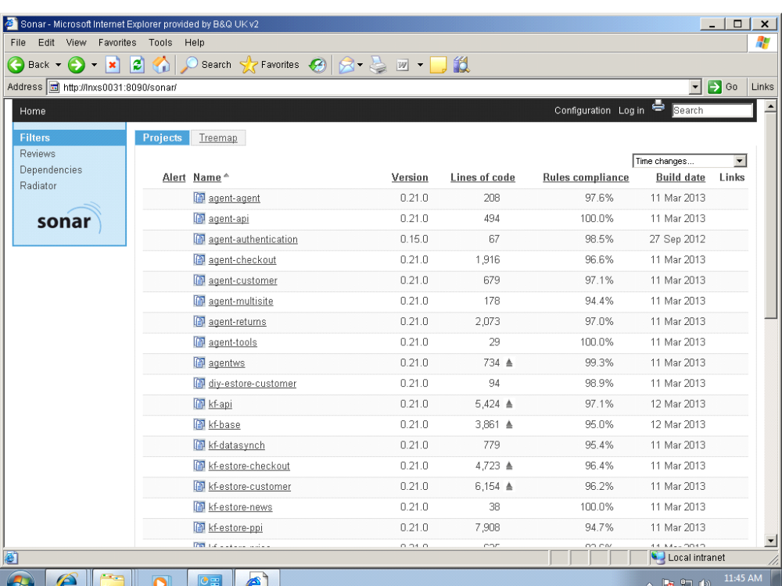

To zoom in, you can simply click on the project and get its dashboard
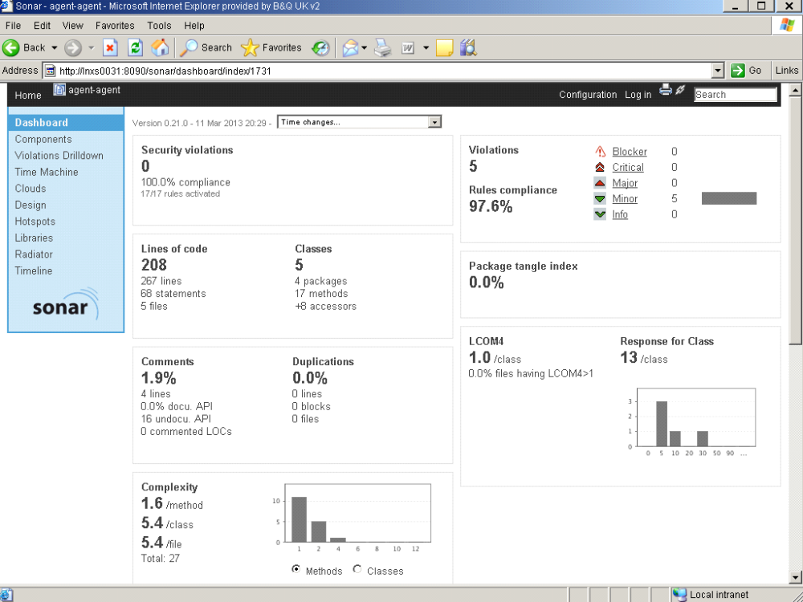

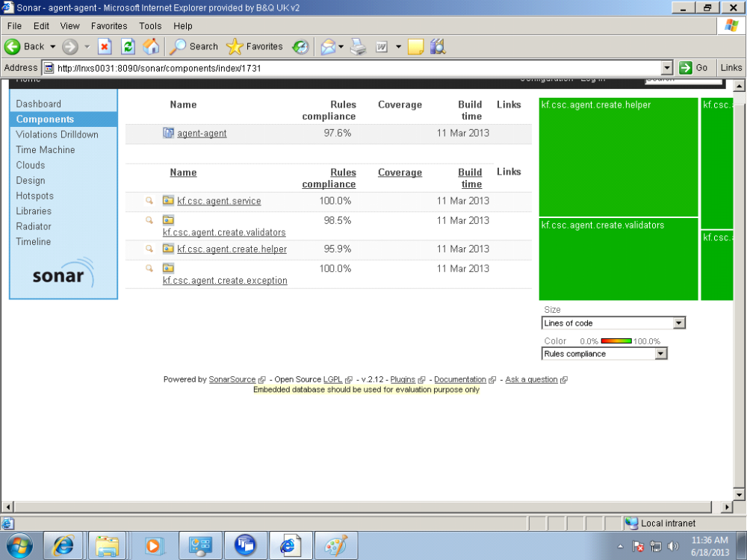

The violations drilldown:

